SOLUBILITY

Introduction
Solutions are defined as a type of homogeneous mixture. Homogeneous mixtures can be divided into two classifications: Colloids and Solutions. A colloid is a mixture that contains particles with diameters ranging from 2 to 500 nm. Colloids appear uniform in nature and have the same composition throughout but are cloudy or opaque. Milk is a good example of a colloid. True solutions have particle sizes of a typical ion or small molecule (~0.1 to 2 nm in diameter) and are transparent, although they may be colored.
Solutions are all around us. Air, for example, is a solution. If you live near a lake, a river, or an ocean, that body of water is not pure H₂O but most probably a solution. Much of what we drink—for example, soda, coffee, tea, and milk are solutions. Solutions are a large part of everyday life. A lot of the chemistry occurring around us happens in solution. In fact, much of the chemistry that occurs in our own bodies takes place in solution, and many solutions are important in healthcare. In our understanding of chemistry, we need to understand a little bit about solutions. In this chapter, you will learn about the special characteristics of solutions, how solutions are characterized, and some of their properties.
The major component of the solution is called solvent, and the minor component(s) are called solute. If both components in a solution are 50%, the term solute can be assigned to either component. When a gaseous or solid material dissolves in a liquid, the gas or solid material is called the solute. When two liquids dissolve in each other, the major component is called the solvent and the minor component is called the solute.
Material exists in three states: solid, liquid, and gas. Solutions also exist in all these states:
- Gaseous mixtures are usually homogeneous and are commonly gas-gas solutions. The atmosphere is a gaseous solution that consists of nitrogen, oxygen, argon, carbon dioxide, water, methane, and some other minor components.
- When molecules of gas, solid or liquid are dispersed and mixed with those of liquid, the homogeneous (uniform) states are called liquid solutions. Solids, liquids and gases dissolve in a liquid solvent to form liquid solutions. In this chapter, most of the chemistry that we will discuss occurs in liquid solutions where water is the solvent.
- Many alloys, ceramics, and polymer blends are solid solutions. Within a certain range, copper and zinc dissolve in each other and harden to give solid solutions called brass.
The maximum amount of a substance that can be dissolved in a given volume of solvent is called solubility. Often, the solubility in water is expressed in gram/100 mL. A solution that has not reached its maximum solubility is called an unsaturated solution. This means that more solute could still be added to the solvent and dissolving would still occur.
A solution that has reached the maximum solubility is called a saturated solution. If more solute is added at this point, it will not dissolve into the solution. Instead it will remain precipitated as a solid at the bottom of the solution. Thus, one can often tell that a solution is saturated if extra solute is present (this can exist as another phase, such as gas, liquid, or solid). In a saturated solution there is no net change in the amount of solute dissolved. In special circumstances, a solution may be supersaturated. Supersaturated solutions are solutions that have dissolved solute beyond the normal saturation point. Usually a condition such as increased temperature or pressure is required to create a supersaturated solution. For example, sodium acetate has a very high solubility at 270 K. When cooled, such a solution stays dissolved in what is called a meta-stable state. However, when a seeding crystal is added to the solution, the extra solute will rapidly solidify.
Explaining Solubility
Typically compounds that have similar polarity are soluble in one another. This can be described by the rule: Like Dissolves Like. This means that substances must have similar intermolecular forces to form solutions. When a soluble solute is introduced into a solvent, the particles of solute can interact with the particles of solvent. In the case of a solid or liquid solute, the interactions between the solute particles and the solvent particles are so strong that the individual solute particles separate from each other and, surrounded by solvent molecules, enter the solution. This process is called solvation and is illustrated in Figure 7.2 (below).
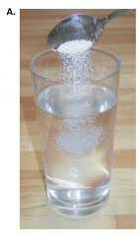
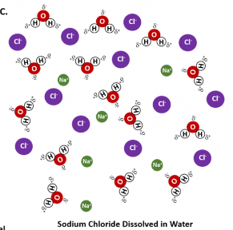
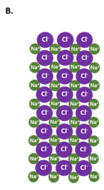
In general polar solvents dissolve polar solutes whereas nonpolar solvents will dissolve nonpolar solutes. Overall, the solution process depends on the strength of the attraction between the solute particles and the solvent particles. For example, water is a highly polar solvent that is capable of dissolving many ionic salts. Figure 7.2 shows the solution process, where water act as the solvent to dissolve the crystalline salt, sodium chloride (NaCl). Note that when ionic compounds dissolve in a solvent they break apart into free floating ions in solution. This enables the compound to interact with the solvent.

Figure 7.2: The Process of Dissolving. When an ionic salt, such as sodium chloride, shown in (A), comes into contact with water, the water molecules dissociate the ion molecules of the sodium chloride into their ionic state, shown as a molecular model in (B) the solid crystalline lattice of sodium chloride, and (C) the sodium chloride dissolved in the water solvent.
In the case of water dissolving sodium chloride, the sodium ion is attracted to the partial negative charge of the oxygen atom in the water molecule, whereas the chloride ion is attracted to the partial positive hydrogen atoms.
Many ionic compounds are soluble in water, however, not all ionic compounds are soluble. Ionic compounds that are soluble in water exist in their ionic state within the solution. You will notice in Figure 7.2 that the sodium chloride breaks apart into the sodium ion and the chloride ion as it dissolves and interacts with the water molecules. For ionic compounds that are not soluble in water, the ions are so strongly attracted to one another that they cannot be broken apart by the partial charges of the water molecules.

Temperature and Solubility
When considering the solubility solids, the relationship of temperature and solubility is not simple or predictable. Figure 7.3 shows plots of the solubilities of several organic and inorganic compounds in water as a function of temperature. Although the solubility of a solid generally increases with increasing temperature, there is no simple relationship between the structure of a substance and the temperature dependence of its solubility. Many compounds (such as glucose and CH₃CO₂Na) exhibit a dramatic increase in solubility with increasing temperature. Others (such as NaCl and K₂SO₄) exhibit little variation, and still others (such as Li₂SO₄) become less soluble with increasing temperature.

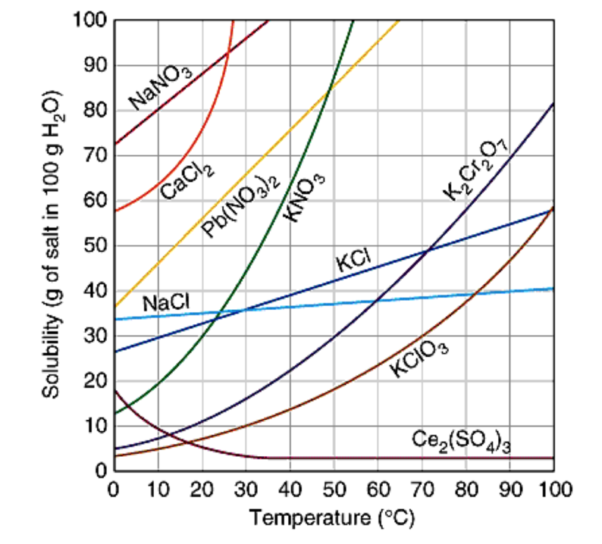

Solubility Rules
The solubility rules can be used to help you predict which ionic compounds will be soluble in water.
The dissociation of soluble ionic compounds gives solutions of these compounds an interesting property: they conduct electricity. Because of this property, soluble ionic compounds are referred to as electrolytes. Many ionic compounds dissociate completely and are therefore called strong electrolytes. Sodium chloride is an example of a strong electrolyte. Some compounds dissolve but dissociate only partially, and solutions of such solutes may conduct electricity only weakly. These solutes are called weak electrolytes. Acetic acid (CH₃COOH), the compound in vinegar, is a weak electrolyte. Solutes that dissolve into individual neutral molecules without dissociation do not impart additional electrical conductivity to their solutions and are called nonelectrolytes. Polar covalent compounds, such as table sugar (C₁₂H₂₂O₁₁), are good examples of nonelectrolytes.

Precipitation Reactions
Solubility Rules
Whether or not a reaction forms a precipitate is dictated by the solubility rules. These rules provide guidelines that tell which ions form solids and which remain in their ionic form in aqueous solution. The rules are to be followed from the top down, meaning that if something is insoluble (or soluble) due to rule 1, it has precedence over a higher-numbered rule.
- Salts formed with group 1 cations and NH⁺⁴ cations are soluble. There are exceptions for certain Li⁺ salts.
- Acetates (C₂H₃O₂⁻), nitrates (NO⁻³), and perchlorates (ClO₄⁻ ) are soluble.
- Bromides, chlorides, and iodides are soluble.
- Sulphates (SO₄²⁻) are soluble with the exception of sulfates formed with Ca²⁺, Sr²⁺, and Ba²⁺.
- Salts containing silver, lead, and mercury (I) are insoluble.
- Carbonates (CO2⁻³), Phosphates (PO3⁻⁴), Sulfides, Oxides, and Hydroxides (OH⁻) are insoluble. Sulfides formed with group 2 cations and hydroxides formed with calcium, strontium, and barium are exceptions.
If the rules state that an ion is soluble, then it remains in its aqueous ion form. If an ion is insoluble based on the solubility rules, then it forms a solid with an ion from the other reactant. If all the ions in a reaction are shown to be soluble, then no precipitation reaction occurs.

Precipitation reactions transform ions into an insoluble salt in aqueous solution. Precipitation refers to a chemical reaction that occurs in aqueous solution when two soluble ions bond together to form an insoluble salt, which is known as the precipitate.
A precipitation reaction can occur when two solutions containing different salts are mixed, and a cation/anion pair in the resulting combined solution forms an insoluble salt; this salt then precipitates out of solution.
The following is a common laboratory example of a precipitation reaction. Aqueous silver nitrate (AgNO₃) is added to a solution containing potassium chloride (KCl), and the precipitation of a white solid, silver chloride (AgCl), is observed:
AgNO_{3 (aq)} + KCl _{(aq)} → AgCl (s) + KNO_{3(aq)}
Note that the product silver chloride is the precipitate, and it is designated as a solid. This reaction can be also be written in terms of the individual dissociated ions in the combined solution. This is known as the complete ionic equation:
Ag⁺ _{(aq)} + NO₃⁻_{(aq)} + K⁺ _{(aq)} + Cl⁻_{(aq)} → AgCl _{(s)} + K⁺ _{(aq)} + NO₃⁻_{(aq)}
A final way to represent a precipitation reaction is known as the net ionic equation. In this case, any spectator ions (those that do not contribute to the precipitation reaction) are left out of the formula completely. Without the spectator ions, the reaction equation simplifies to the following:
(net ionic equation) Ag⁺_{(aq)} + Cl⁻_{(aq)} → AgCl _{(s)}
Observing precipitation reactions can be useful in the laboratory to determine the presence of various ions in solution. For instance, if silver nitrate is added to a solution of an unknown salt and a precipitate is observed, the unknown solution might contain chloride (Cl–).

